CSA1447-COMPILER DESIGN FOR SYNTAX SMITH

PROGRAM 22-29

EXP-22

PROGRAM:

%{

#include <stdio.h>

int comment_count = 0;

FILE *output;

%}

%%

"//".* { comment_count++; } /* Single-line comment */

"/\*"(.|\n)*?"\*/" { comment_count++; } /* Multi-line comment */

. { fputc(yytext[0], output); } /* Copy other content */

%%

int main() {

FILE *input = fopen("input.c", "r"); // Open input file

output = fopen("output.c", "w"); // Open output file to write modified content

if (!input || !output) {

printf("Error opening file.\n");

return 1;

}

yyin = input;

yylex(); // Process input file

printf("Total comment lines removed: %d\n", comment_count);

fclose(input);

fclose(output);

return 0;

}

int yywrap() {

return 1;

}

OUTPUT:

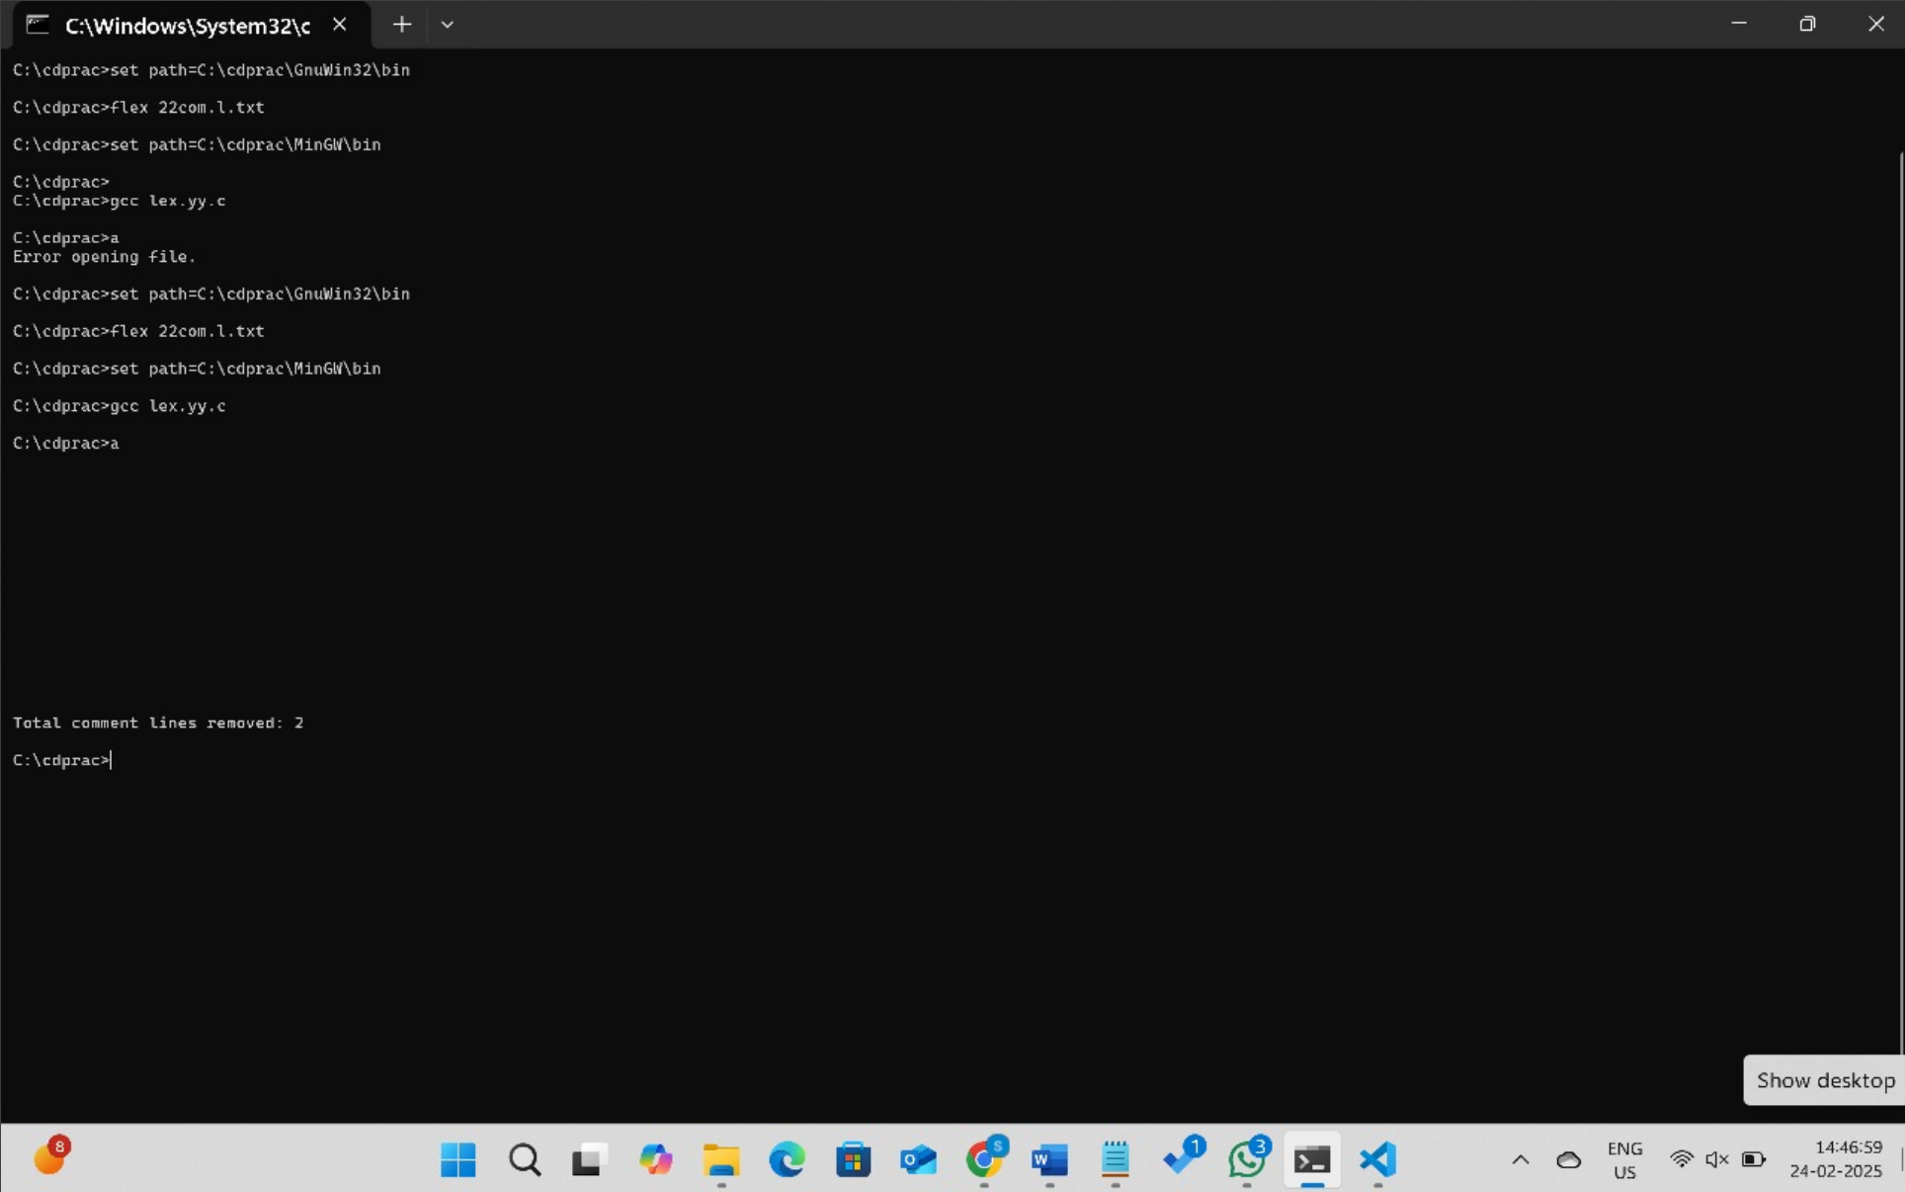

EXP-23

PROGRAM:

%{

#include <stdio.h>

%}

%%

[A-Z]+ { printf("Capital Word: %s\n", yytext); } /* Matches capital words */

.|\n { /* Ignore other characters */ }

%%

int main() {

printf("Enter the input text:\n");

yylex();

return 0;

}

int yywrap() {

return 1;

}

OUTPUT:

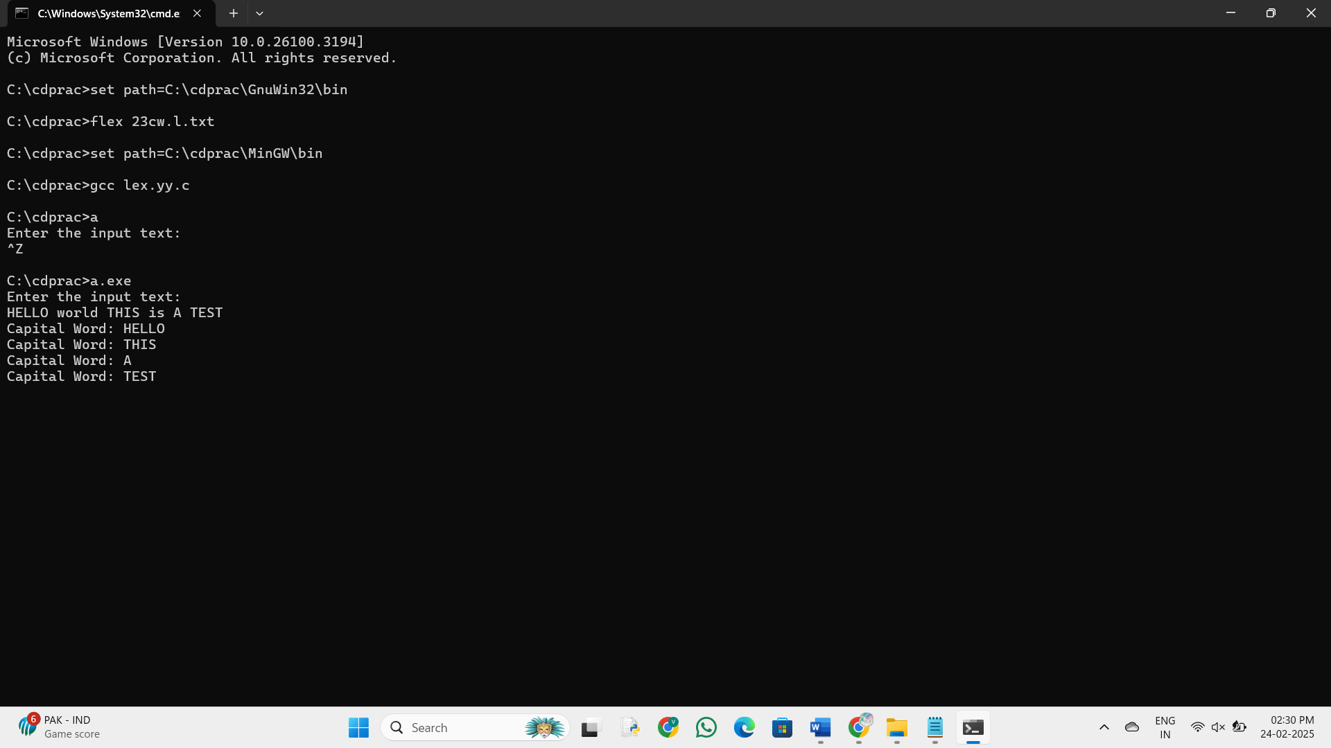

Exp-24

PROGRAM:

%{

#include <stdio.h>

#include <stdlib.h>

%}

%%

[a-zA-Z0-9._%+-]+@[a-zA-Z0-9.-]+\.[a-zA-Z]{2,} { printf("Valid email: %s\n", yytext); }

[^ \t\n]+ { printf("Invalid email: %s\n", yytext); }

[ \t\n] ; /* Ignore whitespace */

%%

int main() {

printf("Enter an email address: \n");

yylex();

return 0;

}

int yywrap() {

return 1;

}

OUTPUT:

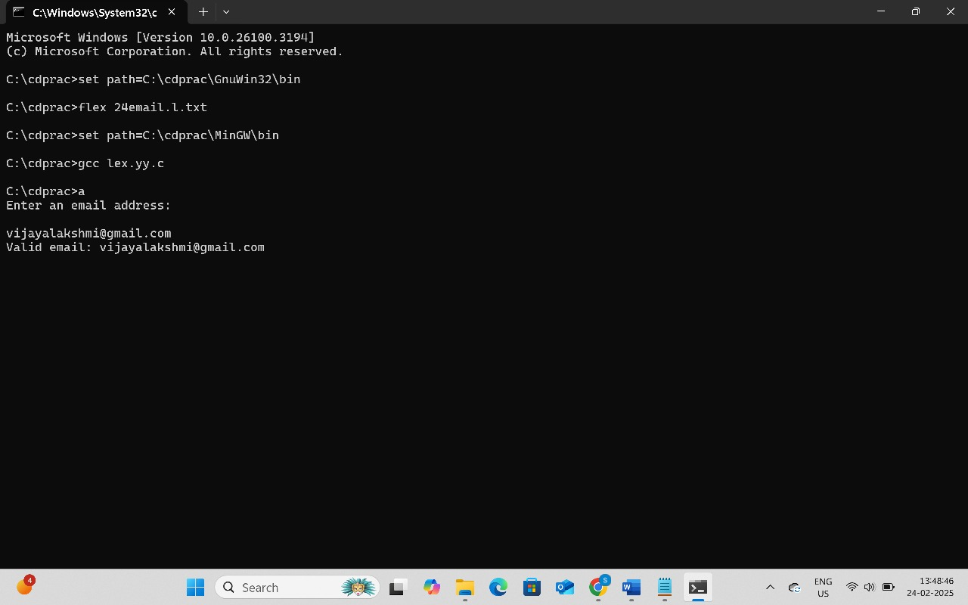

EXP-25

PROGRAM:

%{

#include <stdio.h>

%}

%%

abc { printf("ABC"); } /* Replace "abc" with "ABC" */

.|\n { printf("%s", yytext); } /* Print other characters as they are */

%%

int main() {

printf("Enter the input string:\n");

yylex();

return 0;

}

int yywrap() {

return 1;

}

OUTPUT:

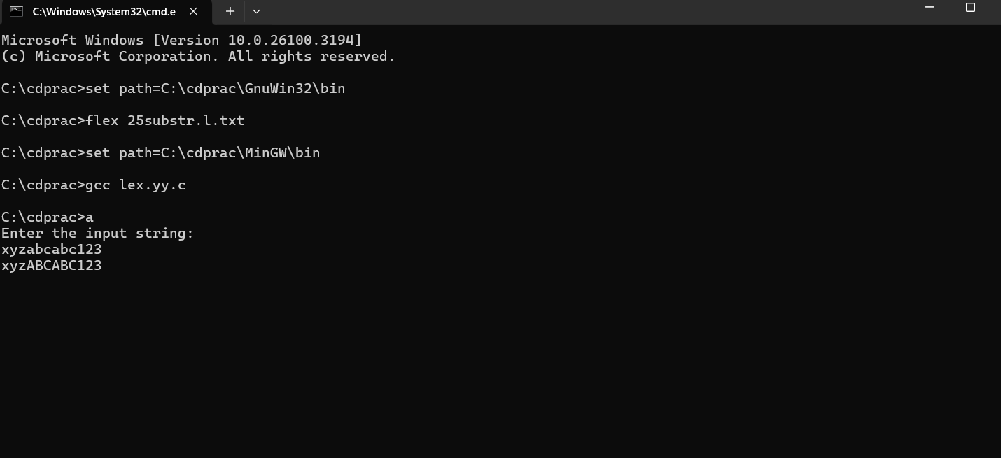

EXP-26

PROGRAM:

%{

#include <stdio.h>

%}

%%

[789][0-9]{9} { printf("Valid Mobile Number: %s\n", yytext); } /* Matches valid mobile numbers */

[0-9]+ { printf("Invalid Mobile Number: %s\n", yytext); } /* Catches invalid numbers */

.|\n { /* Ignore other characters */ }

%%

int main() {

printf("Enter mobile numbers (separated by space or new lines):\n");

yylex();

return 0;

}

int yywrap() {

return 1;

}

OUTPUT:

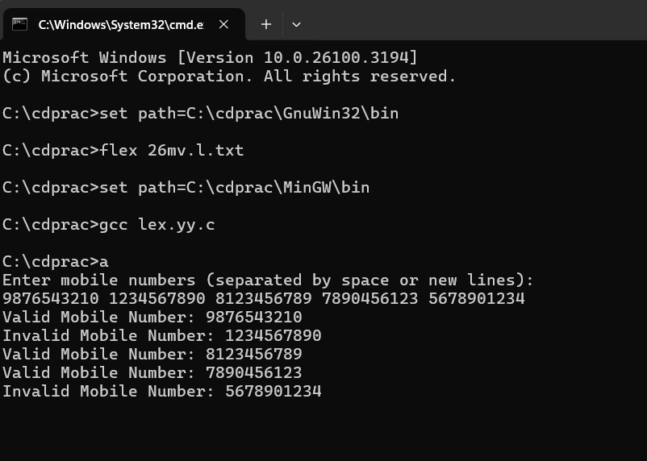

EXP-27

PROGRAM:

%{ #include <stdio.h> %}

%%

"#include" { printf("Preprocessor Directive: %s\n", yytext); } "int"|"void" { printf("Keyword: %s\n", yytext); } [a-zA-Z_][a-zA-Z0-9_]* { printf("Identifier: %s\n", yytext); } [0-9]+ { printf("Number: %s\n", yytext); } "=" { printf("Assignment Operator: %s\n", yytext); } "," { printf("Comma\n"); } ";" { printf("Semicolon\n"); } "(" | ")" { printf("Parenthesis: %s\n", yytext); } "{" | "}" { printf("Brace: %s\n", yytext); } .|\n { /* Ignore other characters */ }

%%

int main() { printf("Lexical Analysis Output:\n"); yylex(); return 0; }

int yywrap() { return 1; }

Op:

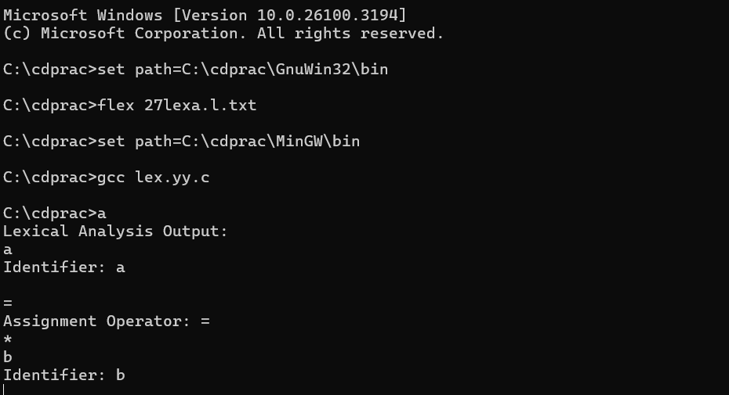

Exp-28:

%{ #include <stdio.h> int vowels = 0, consonants = 0; %}

%%

[AEIOUaeiou] { vowels++; } [a-zA-Z] { consonants++; } .|\n { /* Ignore other characters like spaces, digits, and punctuation */ }

%%

int main() { printf("Enter a sentence:\n"); yylex(); // Start lexical analysis printf("Number of vowels: %d\n", vowels); printf("Number of consonants: %d\n", consonants); return 0; }

int yywrap() { return 1; }

Op:

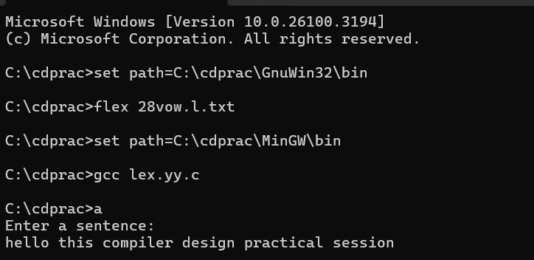

EXP-29

PROGRAM:

%{

#include <stdio.h>

#include <string.h>

// List of C keywords

char *keywords[] = {

"auto", "break", "case", "char", "const", "continue", "default", "do",

"double", "else", "enum", "extern", "float", "for", "goto", "if",

"inline", "int", "long", "register", "restrict", "return", "short",

"signed", "sizeof", "static", "struct", "switch", "typedef", "union",

"unsigned", "void", "volatile", "while"

};

int is_keyword(char *word) {

for (int i = 0; i < 32; i++) {

if (strcmp(word, keywords[i]) == 0)

return 1;

}

return 0;

}

%}

%%

[a-zA-Z_][a-zA-Z0-9_]* {

if (is_keyword(yytext))

printf("Keyword: %s\n", yytext);

else

printf("Identifier: %s\n", yytext);

}

[ \t\n] ; // Ignore spaces, tabs, and newlines

. ; // Ignore other characters

%%

int main() {

printf("Enter the input code:\n");

yylex();

return 0;

}

int yywrap() {

return 1;

}

OUTPUT: 